# Acme Handy Worker – Json

The implemented utility is GSON´s Java Library. This library lets us to parse objects in java to json data and viceversa. Thanks to “SchemaPrinter” class, the generated JSON is shown with all the neccesary characters on the console.

Let´s see the example we attach you on this PDF.

1. We would like to make a FixUp – Task.

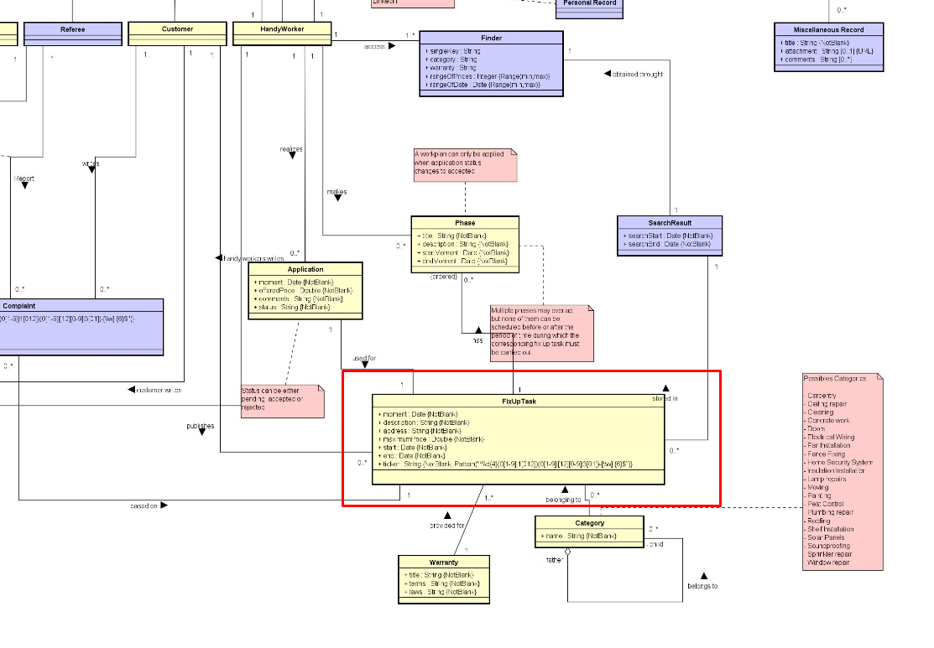

1. If we have a look to the image before, we see that FixUp – Task has 3 different important relations (a part from all its predeterminate attributes). This is become into our Java Model as different attributes of different types.

* Warranty
* Category
* Phases List (We must take into account that we have to make every object of the list before, so we will have to work with Phase Object)

1. Once we have this, we must implement before creating our task, every of the following ítems before. It means, we have to implement following the next order:
2. As a result of implementing the last objects and the attributes of the model, we have a Fix-Up Task created.
3. To see how it works you have got available a JUnit4 test class in the following route: Resources/src/test/java/sample/Prueba.java. You must be carefull with the console, because this shorts some words.

